**→ Application of Autoencoders – Denoising using MNIST dataset :**

**→ Main Algo of autoencoders :**

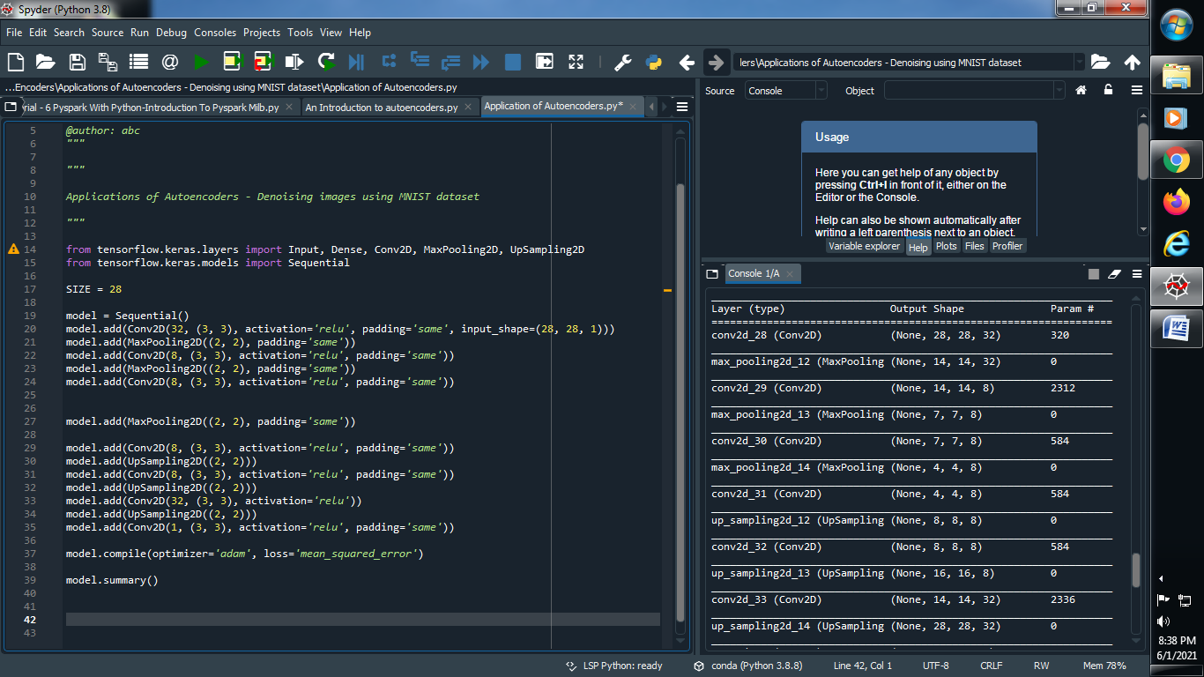**s**

**Output :**

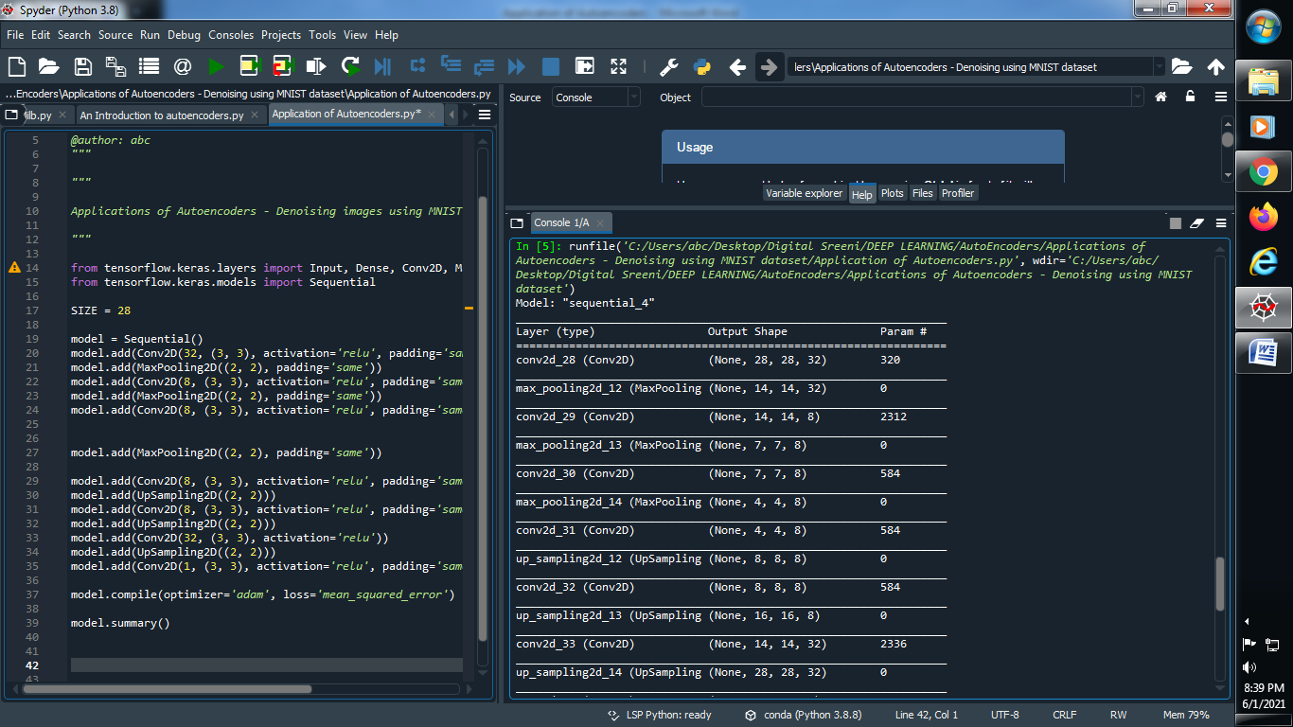

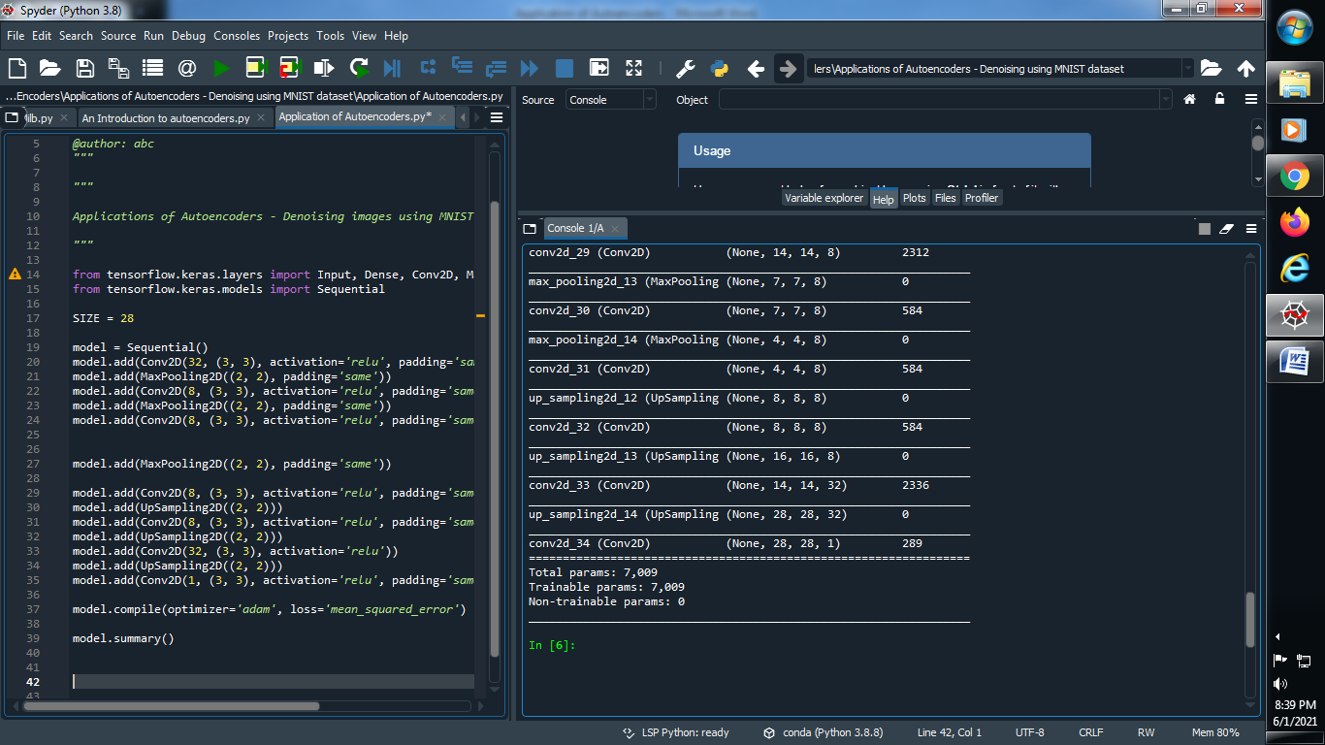

**####################################################################################**

**(1) import library and load our mnist dataset :**

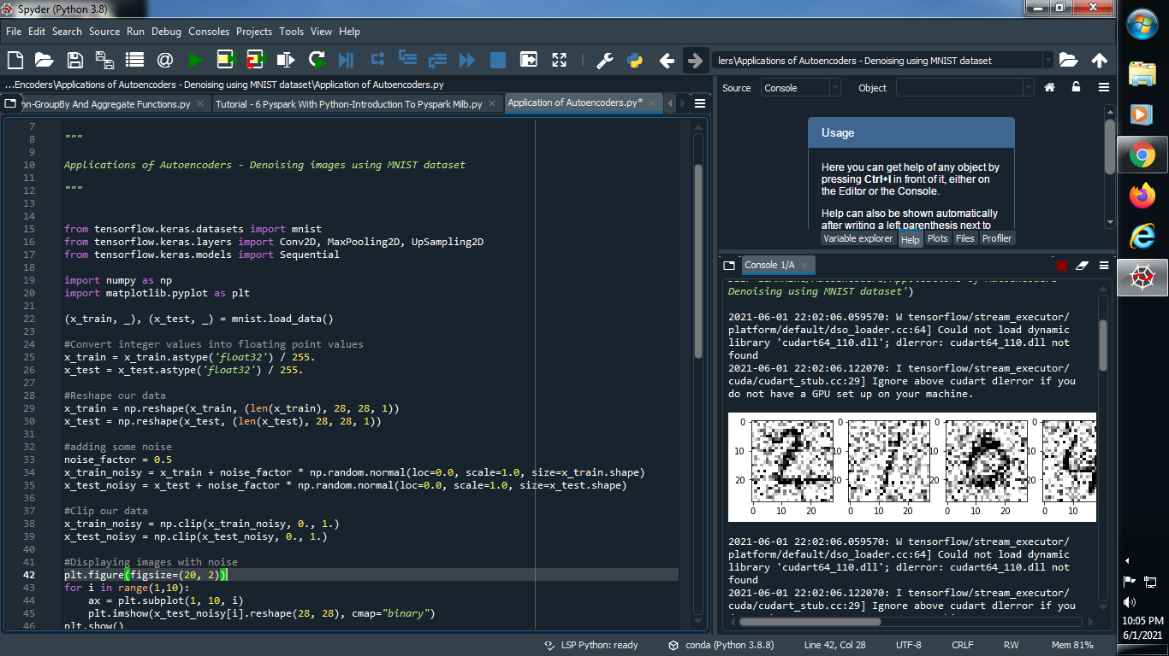

**(2) Convert our data value into floating point and normalize it :**

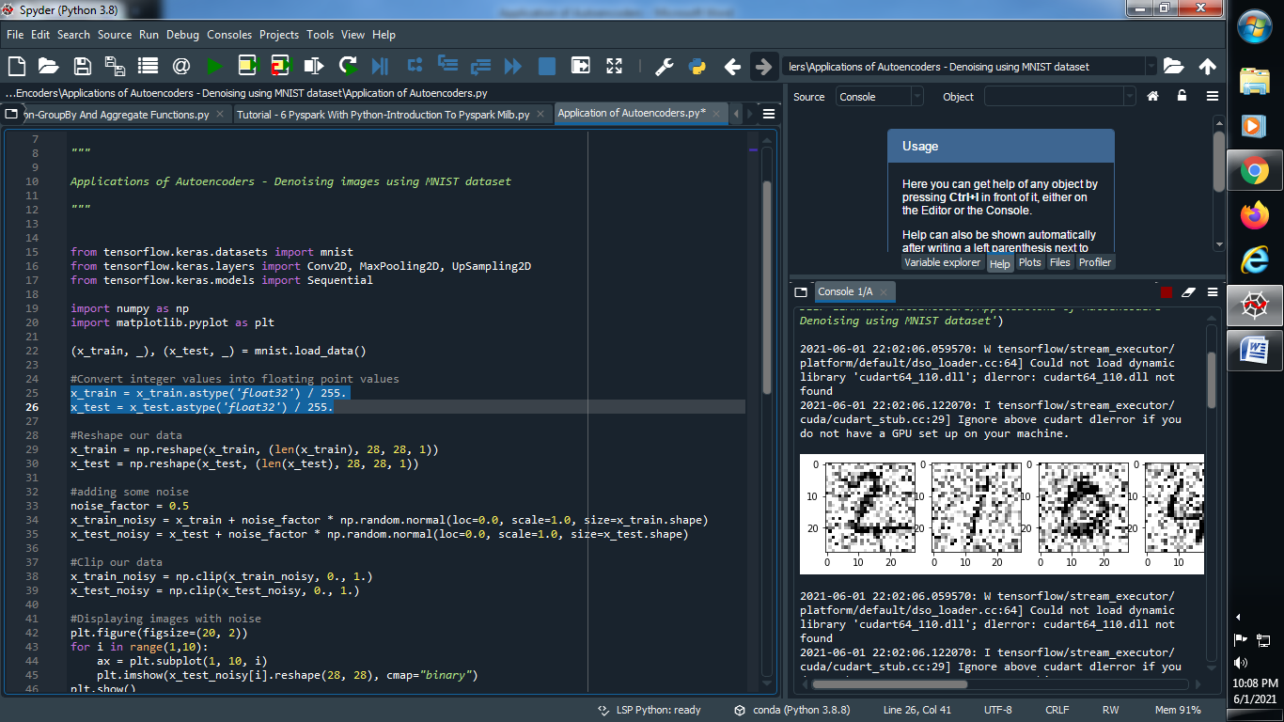

**(3) Reshape our data :**

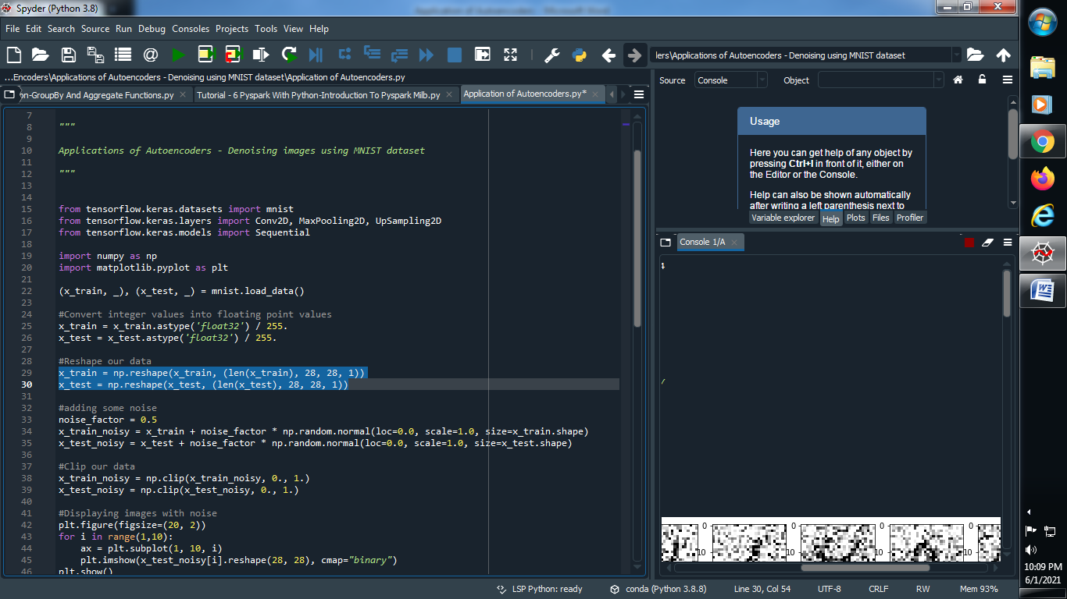

**(4) Adding some noise :**

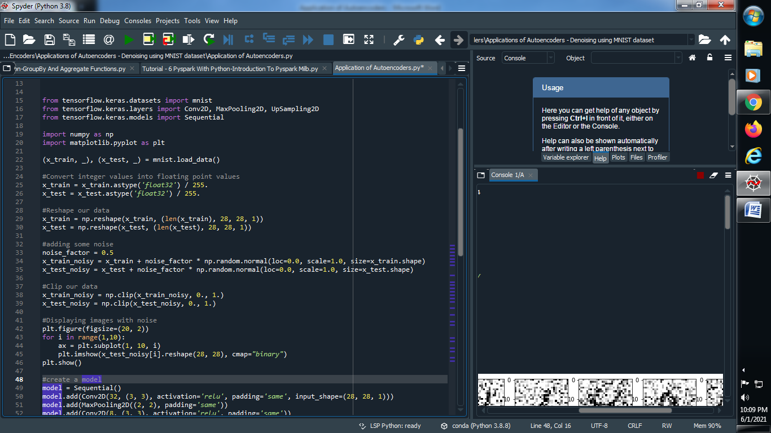

**(5) Clip to our data :**

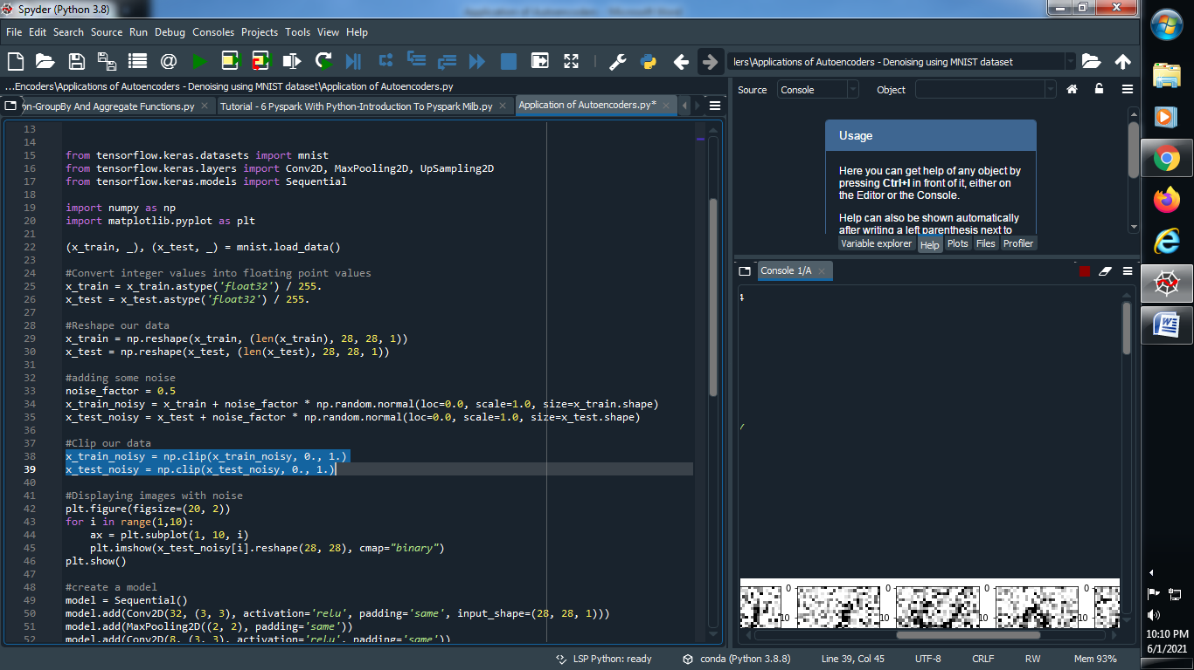

**(6) Displaying images with noise :**

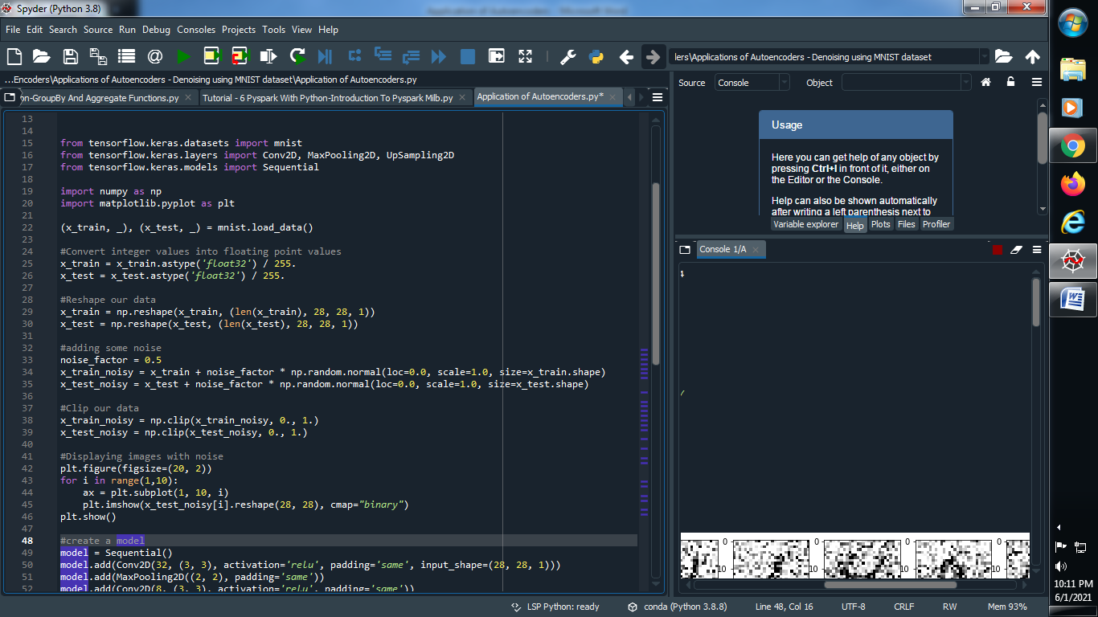

**(7) Create a model :**

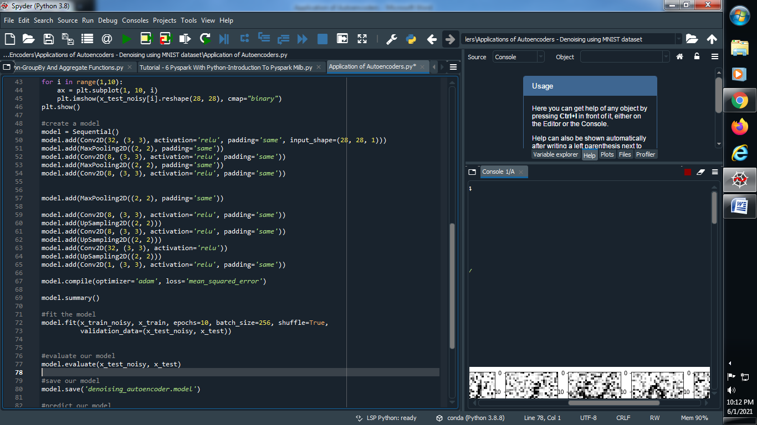

**(8) Fit the model :**

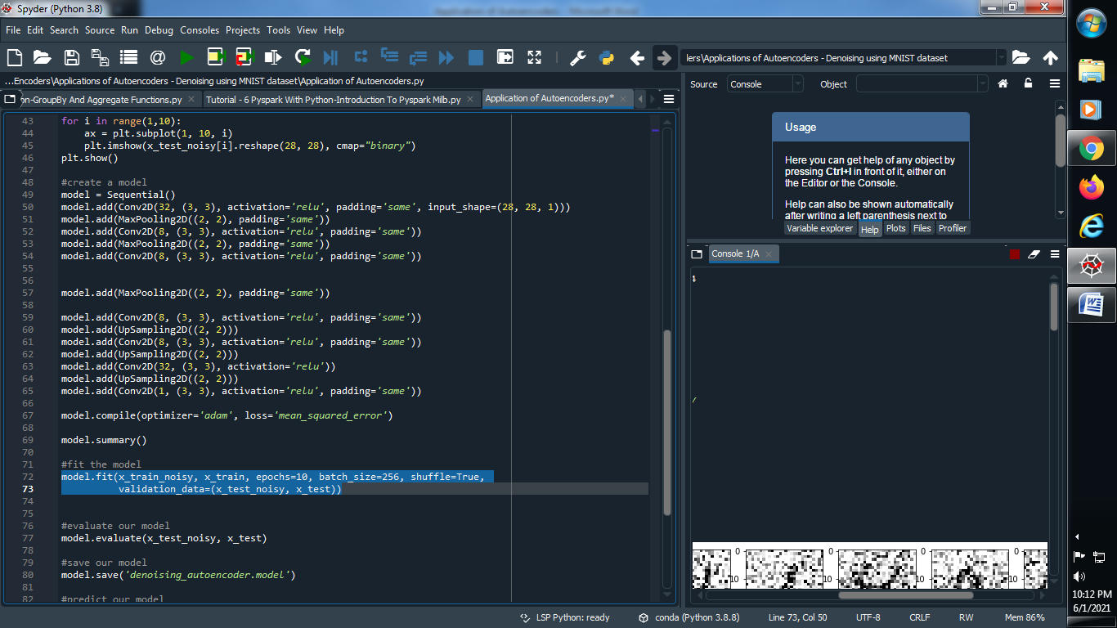

**(9) Evaluate our model :**

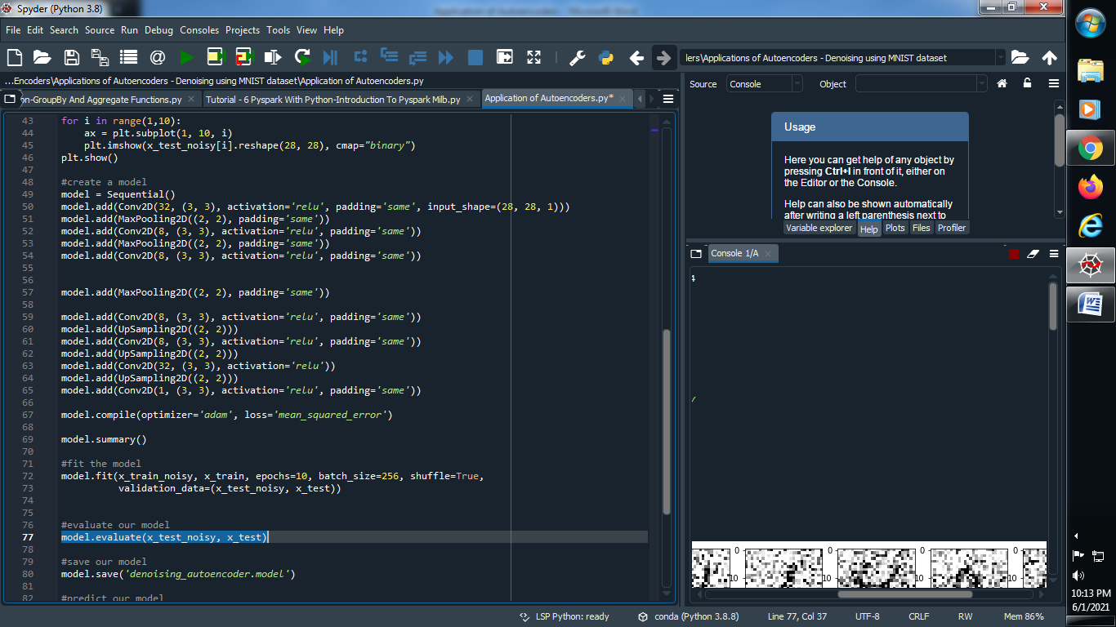

**(10) Save the model :**

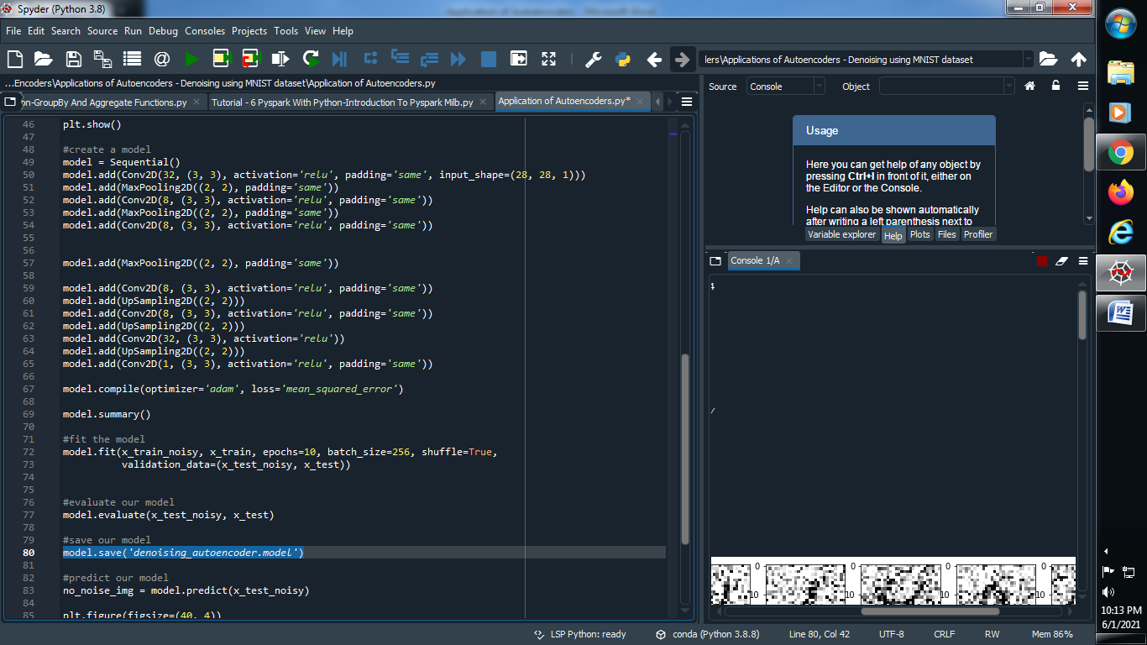

**(11) Predict our model :**

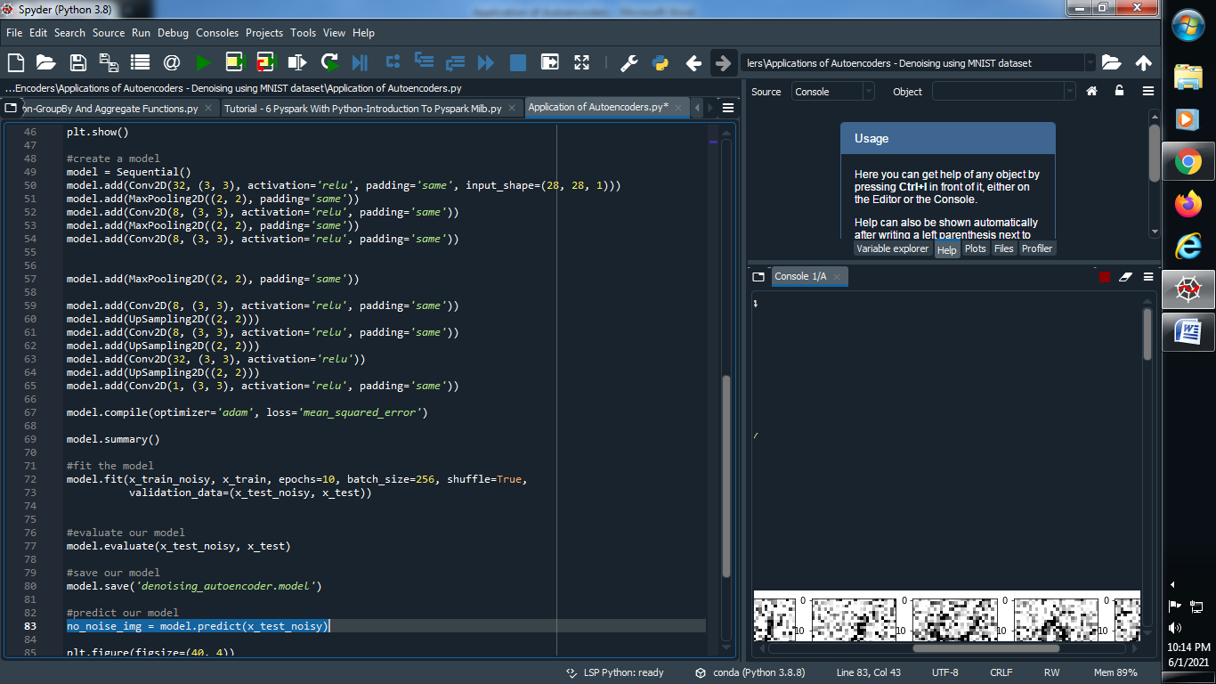

**(12) Let’s see our model :**

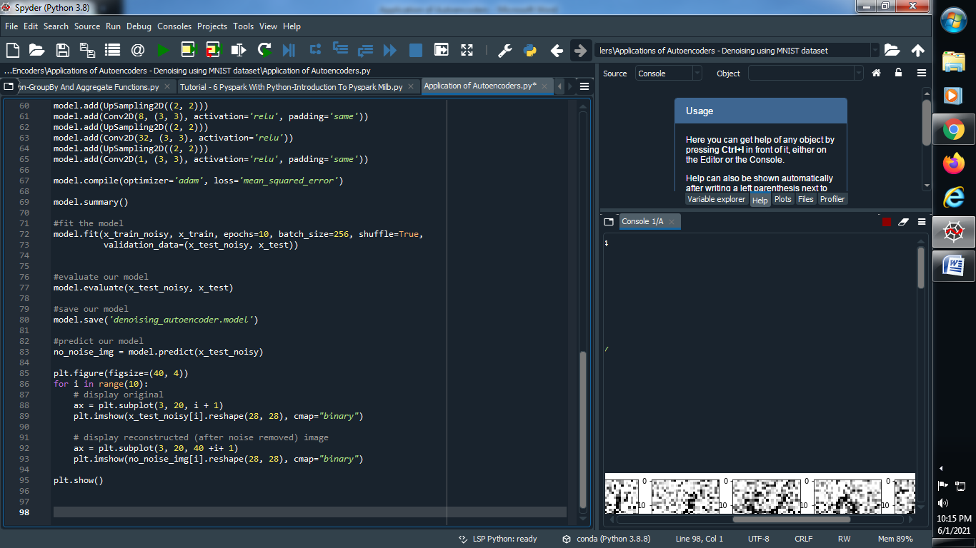

**Output :**

